# Instructions: Weekly Bills of Mortality

You have been assigned one of the weekly Bills of Mortality to contribute to our class-sourced database of the London plague statistics from 1665.

Once you have logged into Remote Desktop and opened oXygen XML Editor (see on separate instruction sheet), go to Canvas and open the assignment “Collaborative digital edition: Bills of Mortality”.

In that assignment page, scroll down to where you see a link for the file Bills-Mortality-00.xml. Click to download the file. Then go to oXygen, File -> Open, and locate Bills-Mortality-00.xml in your Downloads folder. Open it in oXygen.

Your oXygen window will be cluttered with a bunch of boxes around the sides and possibly the bottom. Hit the X in the upper right corner of each of these until they are all gone; you don’t need them.

Now you should see your document open and taking up the whole oXygen screen:

You are going to treat this as a form and enter the data from your Bill of Mortality.

Start by changing the file name in one way only. Go to File -> Save As.

First, select where you will be saving the document: it will be saved to your OneDrive folder so you have access to it later. Put it wherever you think you will be able to find it again. Ask a fellow student for help if you need guidance on this.

Next, before you click Save, where you see the file name, change the 00 at the end to the number at the upper left corner of your Bill of Mortality, next to the word London. If you have a single-digit number, enter it as 01, 02, etc., to keep two digits in the file name:

Now click “Save”. You’ll see the new file name in the tab at the top of the file in oXygen.

Next, you need to enter the same week number, and the date the week **started**, in your XML file. These go inside the quotation marks and replace the filler text there:

**Notes on date format:** The date format **must** be 4-digit year, then 2-digit month, then 2-digit day! The computer needs them in this format or it can’t put them in order.  
**If your dates are between January 1 and March 24**, they calculated years differently then and we need to account for that. New Year’s Day was (strangely) March 25. It wasn’t moved to January 1st until 1752! So we need to convert “Old Style dates” to “New Style dates”. What the document calls January 3, 1664, is really January 3, 1665, the way we measure things. Historians have to make this conversion, and so do you. So **if** your date is within this range, add one to the year to account for this.

Enter your name between the quotes in the <encoder> field. This will ensure that you get credit for your work. Save your work now, and often as you proceed.

Next, you will enter the number of total burials and plague burials for each parish in and around the city of London. These are in several columns in the original document but in a single column in your XML file. Enter each number within the quotation marks, replacing “x”, so that bur=”x” becomes bur=”2” etc. Where there is no number on your document, insert a zero in your XML file:

These will run all the way to the bottom of the first page of your Bill of Mortality. Fill in the totals also at the end of each section.

But wait! There’s more!

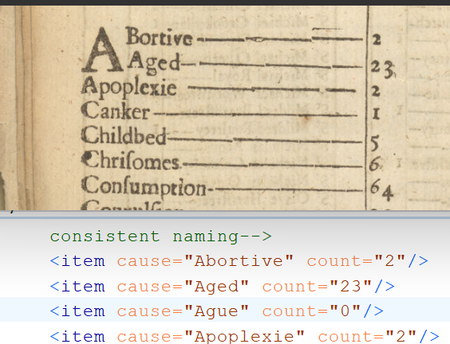Now flip your Bill of Mortality over to the back, where you will see the heading “The Diseases and Casualties this Week.” This will be a little more challenging, because the list of causes of death varies slightly from week to week.

Copy in the numbers, replacing the x, as before. If a given cause of death is not listed that week, enter “0”, as in the case of Ague here:

There may also be causes of death that do not appear in your XML file, and you will need to add a line for them. Just copy the line above where you need to insert it (highlight, then Ctrl-c), make a new line, and paste in the copy (Ctrl-v). Type in the name of the cause of death and the number of recorded deaths as normal.

At the bottom of the page, and the bottom of the XML file, there are weekly summaries for total christenings (baptisms) and burials. Enter those as well. Save your work.

Now check in the upper right-hand corner of your oXygen screen. There’s a color-coded square. You want this square to be **green.** If it is, then congratulations – you’re done with the assignment. Make sure it is saved, and submit it in Canvas the same way you submit any other assignment.

If the square is **red**, it means you made an error somewhere: perhaps you deleted some quotation marks, for example. If so, you should see some red lines on the scroll bar that will help you locate the errors in your document. Ask for help if you’re not sure why it’s red or how to fix it. Once you have fixed the errors and have a green square, save and submit your work (see above).

# What if I’m not done within our class time?

Save your work before you leave; you should be able to locate it again in OneDrive. As a backup, also go ahead and upload it to Canvas, but write “not finished” in your submission comment box. You should be able to download it from Canvas to keep working on it and re-submit it when done.

To keep working, you have three options:

1. Come back to a Pitt computer lab at another time, sign into Virtual Desktop there, open oXygen, open your file, and carry on. Submit to Canvas when you’re done.
2. You can also access Virtual Desktop over the web from a non-Pitt computer at <https://client.wvd.microsoft.com/arm/webclient/index.html> . Carry on and submit to Canvas when you’re done.
3. If for some reason you can’t get to Virtual Desktop, you should be able to open your .xml file in a plain text editor, such as Notepad (Windows/PC) or TextEdit (on a Mac). Do NOT use MS Word or any other word processor! In a plain text editor, you’ll lose some formatting but in theory it should work just fine. Be sure it is still saved with a file name that ends .xml rather than .txt or anything else. Submit to Canvas when you’re done.